Faculty of Computing

ARQAM WAHEED - 553514
CS220: Database Systems
Class: BSDS
Lab 02: File-Based Data Storage and Introduction to Database Concepts

Date: Jan 26, 2024

Instructor: Dr. Fahad Ahmed Satt

File Handling in Java/C++ and Understanding File-Based Data Storage as a Foundation for DBMS

Lab Tasks

Task 1
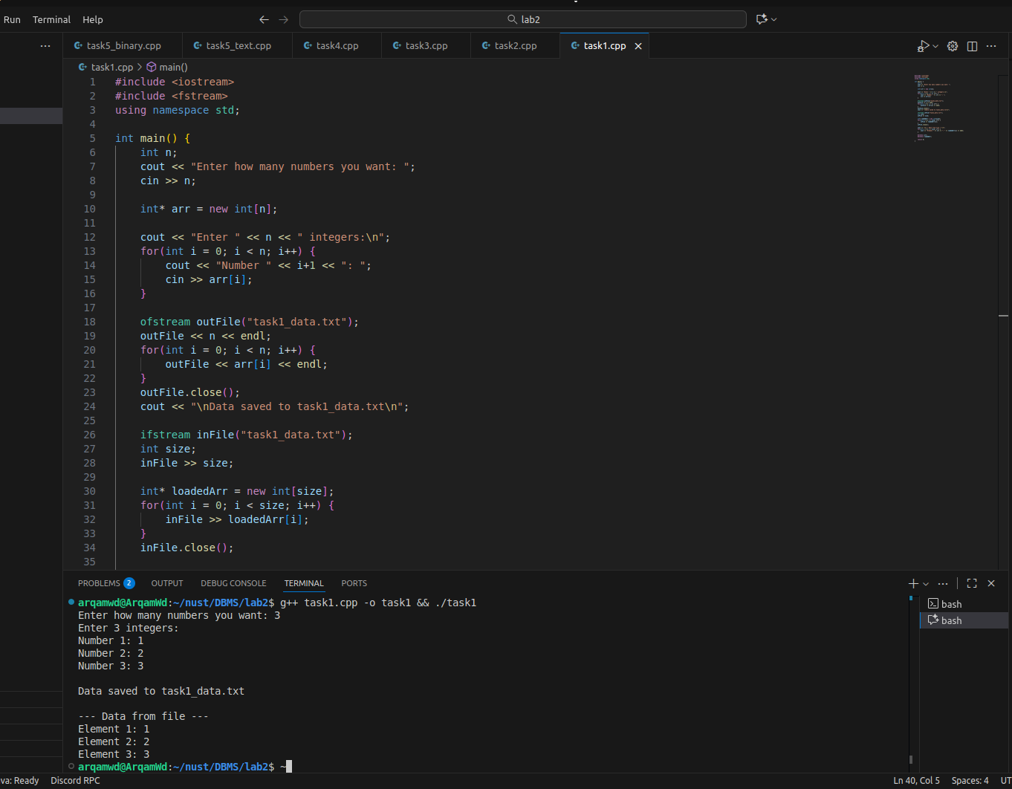
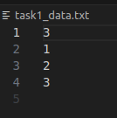

Task 2
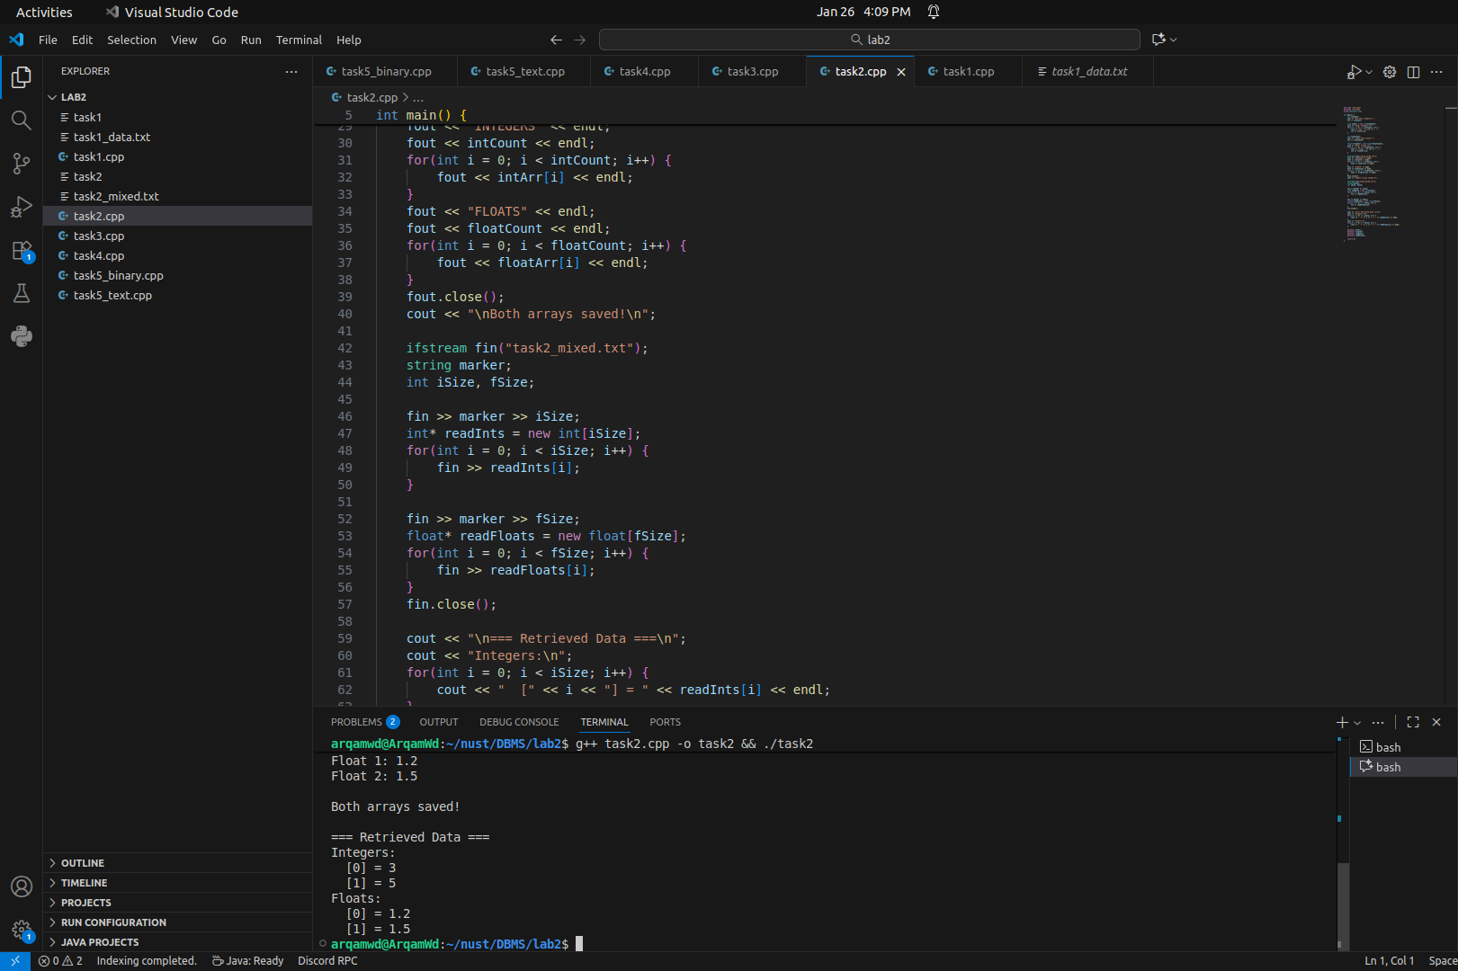

Task 3
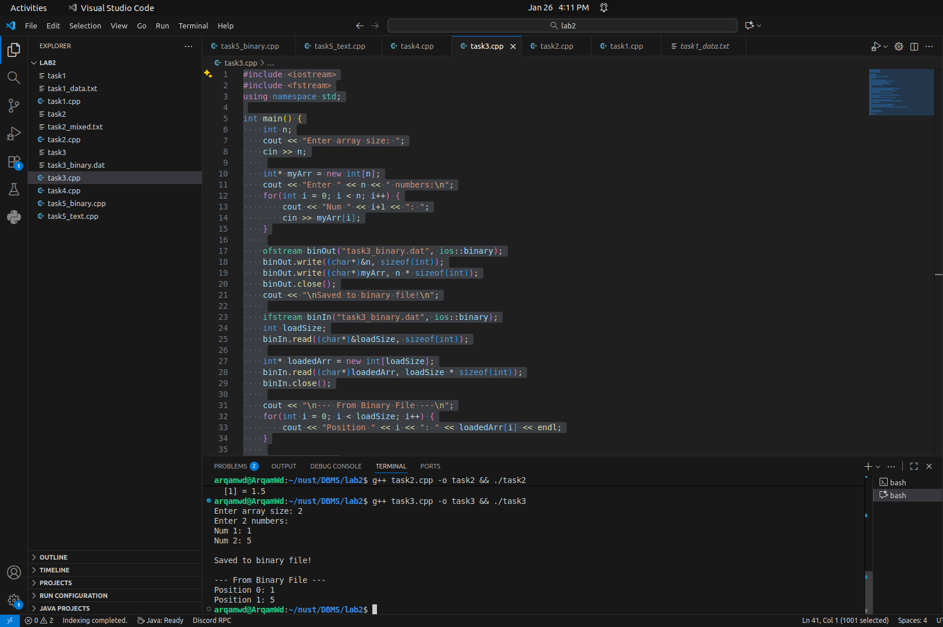

Task 4
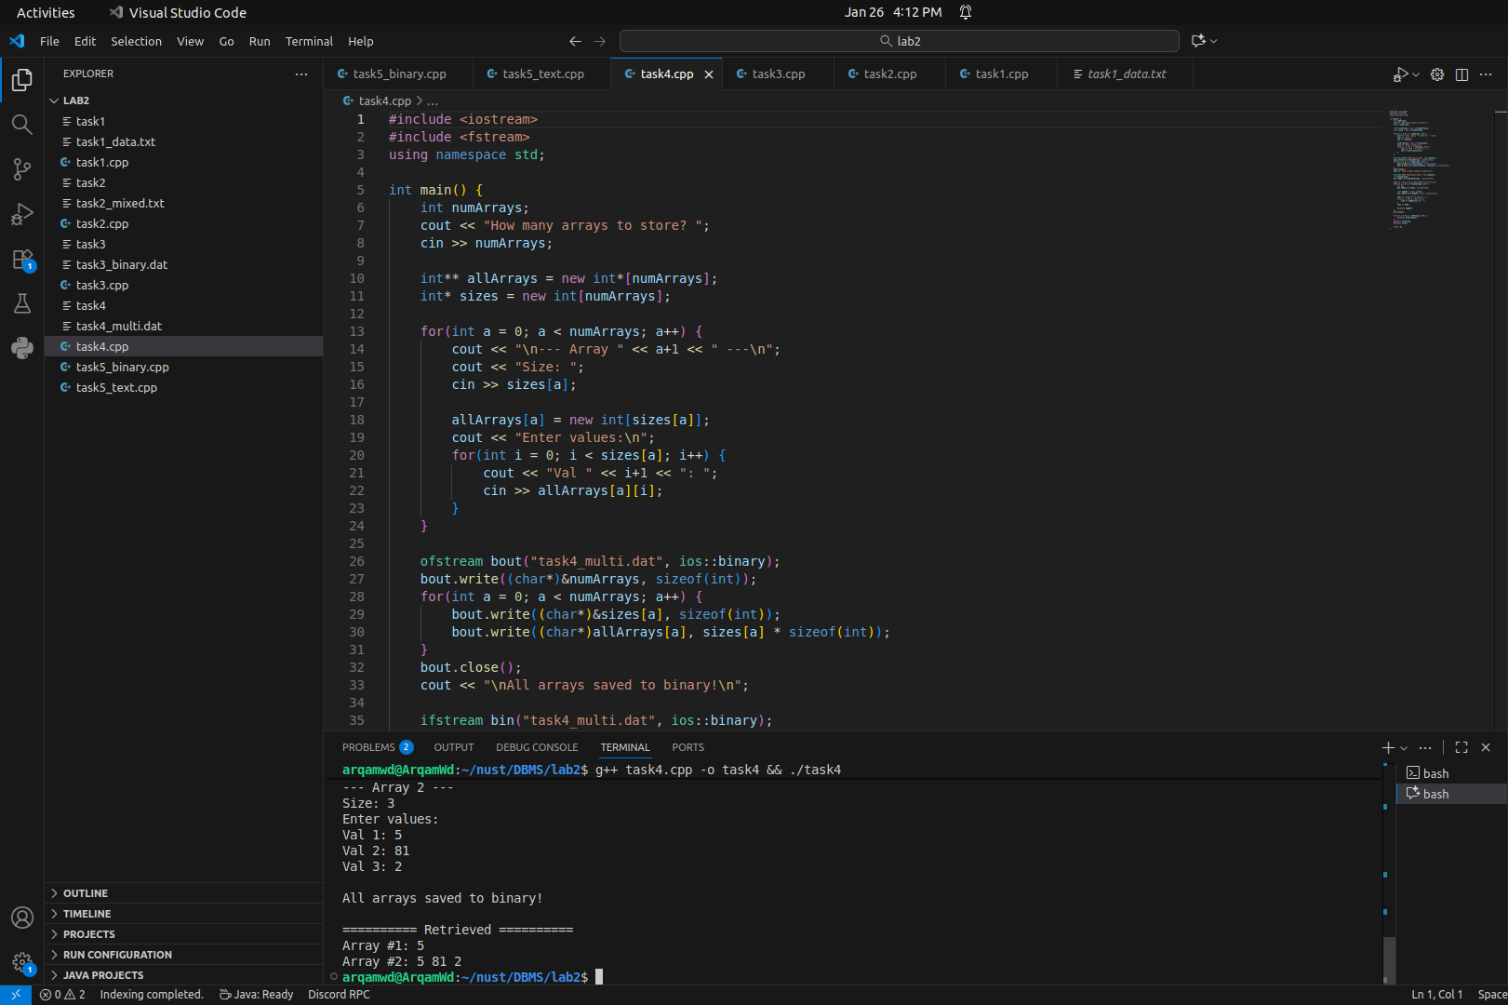

Task 5
Text file version:
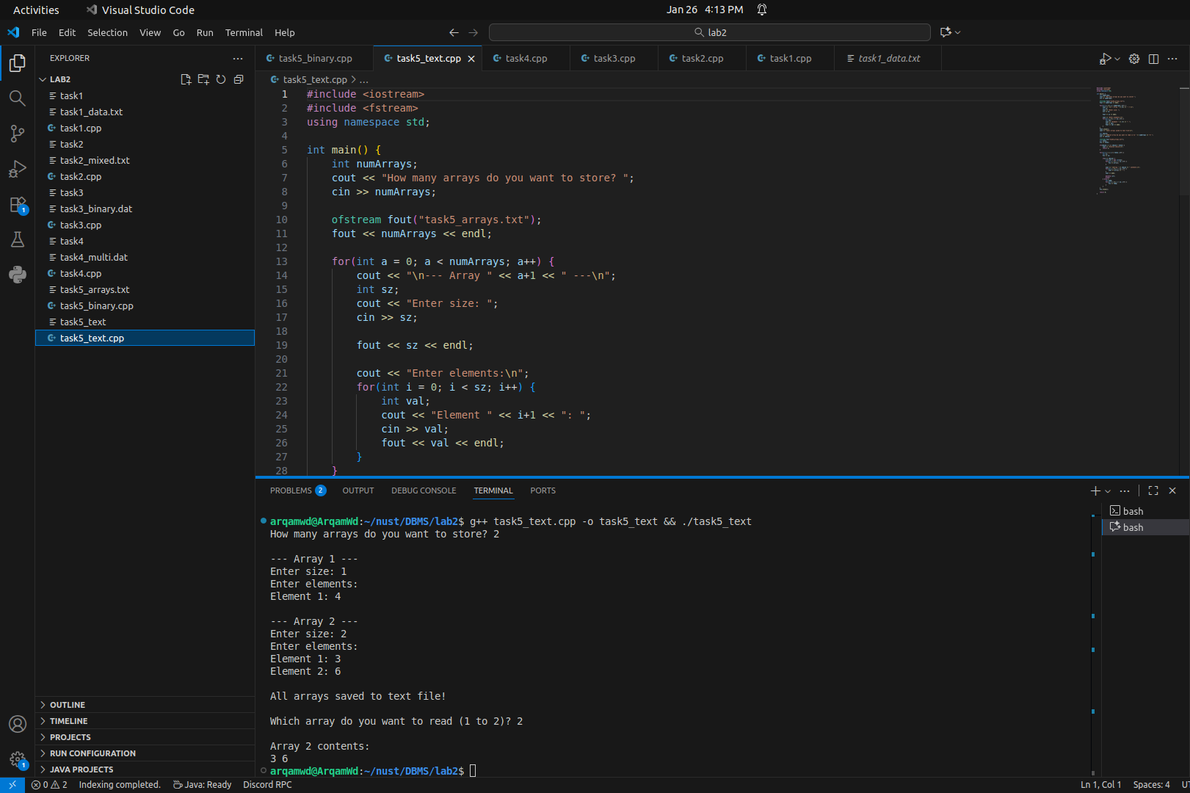

Binary Version:
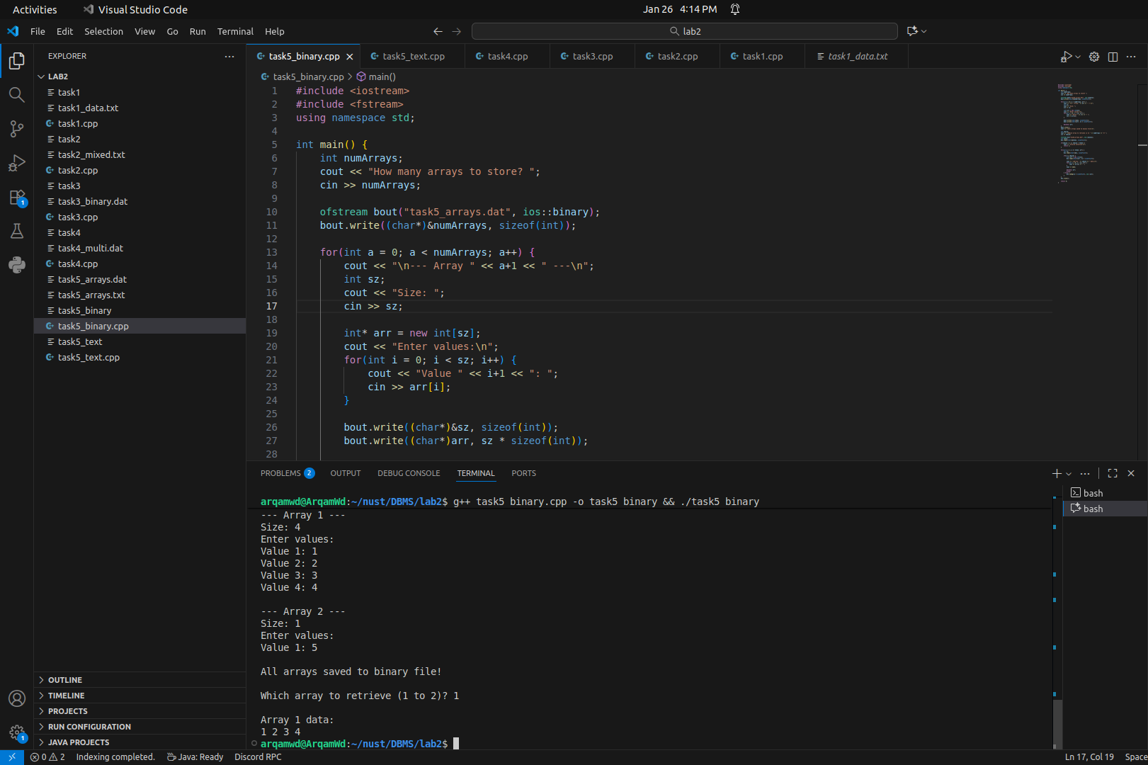

Task 6
Submitted the report alongside this document

